Page 1 of 43 - Cover Page

Atharva Kulkarni
37 Pages
6,630 Words
40,029 Characters
GovAssist: AI Chatbot for E-Governance
Ajeenkya D Y Patil University, Pune
Document Details
Submission ID trn:oid:::3618:124683685
Submission Date
Dec 17, 2025, 2:28 PM GMT+5:30
Download Date
Dec 17, 2025, 2:41 PM GMT+5:30
File Name
GOVASSIST_blackbook.pdf
File Size
1.2 MB
Page 1 of 43 - Cover Page

14% Overall Similarity
The combined total of all matches, including overlapping sources, for each database.
Filtered from the Report
Bibliography
Quoted Text
Cited Text
Abstract
Methods and Materials

Match Groups
63
Not Cited or Quoted 14%
Matches with neither in-text citation nor quotation marks
0
Missing Quotations 0%
Matches that are still very similar to source material
0
Missing Citation 0%
Matches that have quotation marks, but no in-text citation
0
Cited and Quoted 0%
Matches with in-text citation present, but no quotation marks
Top Sources
13
%
Internet sources
%
6
Publications
%
0
Submitted works (Student Papers)

Integrity Flags
0 Integrity Flags for Review
No suspicious text manipulations found.

Our system's algorithms look deeply at a document for any inconsistencies that would set it apart from a normal submission. If we notice something strange, we flag it for you to review.
A Flag is not necessarily an indicator of a problem. However, we'd recommend you focus your attention there for further review.





The sources with the highest number of matches within the submission. Overlapping sources will not be displayed.
Match Groups
63
Not Cited or Quoted 14%
Matches with neither in-text citation nor quotation marks
0
Missing Quotations 0%
Matches that are still very similar to source material
0
Missing Citation 0%
Matches that have quotation marks, but no in-text citation
0
Cited and Quoted 0%
Matches with in-text citation present, but no quotation marks
Top Sources
13
%
Internet sources
6
%
Publications
%
0
Submitted works (Student Papers)
Top Sources
1
Internet
www.coursehero.com
5
%
2
Internet
codevoweb.com
%
1
3
Internet
github.com
%
<1
4
Internet
medium.com
<1
%
5
Publication
Hangseo Choi, Jongpil Jeong. "Domain-Specific Manufacturing Analytics Framewo…
<1
%
6
Internet
modal.com
%
<1
7
Internet
www.aun.edu.eg
<1
%
8
Publication
Abdelgawad, Moataz M.. "Organizational Leadership in the Artificial Intelligence …
<1
%
9
Internet
studentsrepo.um.edu.my
<1
%
10
Internet
adisubru.github.io
<1
%

11 Internet
objectcomputing.com
12
Publication
Silva, José Hugo Sousa. "Innovative Solutions for Healthcare Data Management: T…
<1
%
13
Internet
sparklyn.com.ng
<1
%
14
Internet
www.kdnuggets.com
<1
%
15
Internet
files.core.ac.uk
%
<1
16
Internet
gitext.gfz-potsdam.de
<1
%
17
Internet
dspace.cvut.cz
<1
%
18
Internet
figshare.mq.edu.au
%
<1
19
Internet
ijirt.org
<1
%
20
Internet
www.lambdatest.com
%
<1
21
Internet
ijstm.com
<1
%
22
Internet
www.theseus.fi
<1
%
23
Internet
api.repository.cam.ac.uk
<1
%
24
Internet
blog.enterprisedna.co
<1
%
25 Internet
digital.library.unt.edu
26
Internet
dokumen.tips
<1
%
27
Internet
packages.msys2.org
<1
%
28
Internet
thesis.unipd.it
<1
%
29
Publication
Anitha S. Pillai, Roberto Tedesco. "Machine Learning and Deep Learning in Natur…
%
<1
30
Publication
Nicolas Bono Rossello, Anthony Simonofski, Annick Castiaux. "Artificial intelligen…
<1
%
31
Internet
mafiadoc.com
<1
%
32
Internet
www.slideshare.net
%
<1
33
Publication
Ulfert Onken, Kai Fischer, Jürgen Rarey. "Estimation of Physical Properties", Wiley…
<1
%
34
Internet
link.springer.com
%
<1
35
Internet
python.langchain.com
<1
%
36
Internet
vbook.pub
<1
%
37
Internet
gitter.im
<1
%
38
Publication
Arindam Ganguly. "Scaling Enterprise Solutions with Large Language Models", Sp…
<1
%
39 Publication
Pavan Kumar Narayanan. "Chapter 10 Engineering Machine Learning and Data R…
40
Internet
docs.perplexity.ai
<1
%
41
Internet
a2aprotocol.ai <1%

Title- “GovAssist: AI Chatbot for E-Governance”

Atharva Nitin Kulkarni
2023-B-02062004 B. Tech Computer Engineering (CSE)

Rushikesh Kishor Pattiwar
2023-B-05102002 B. Tech Computer Engineering (CSE)

Priti Shahaji Satre

2022-B-19072003B B. Tech Computer Engineering (CSE)


Page 7 of 43 - Integrity Submission

“GovAssist: AI Chatbot for E-Governance”

10 This is submitted in partial fulfilment of the requirements of the degree of Bachelor of Technology
in
Computer Science and Engineering
By

Atharva Nitin Kulkarni: 2023-B-02062004 Rushikesh Kishor Pattiwar: 2023-B-05102002
Priti Shahaji Satre: 2022-B-19072003B

Under the Supervision of
Dr. Prashant Kumbharkar



Academic Year 2025 - 2026

School of Computer Science and Technology
Page 8 of 43 - Integrity SubmissionAjeenkya DY Patil University, Pune


Date:

CERTIFICATE
1

This is to certify that the dissertation entitled “GovAssist: AI Chatbot for EGovernance” is a Bonafide work of “Atharva Nitin Kulkarni (2023-B-02062004), Rushikesh Kishor Pattiwar (2023-B-05102002), Priti Shahaji Satre (2022-B19072003B)”, submitted to the School of Computer Science and Technology,
1 | Ajeenkya D Y Patil University, Pune in partial fulfilment of the requirement for the  award of the degree of “Bachelor of Technology in Computer Science
Engineering”.

Dr. Prashant Kumbharkar
Project Supervisor

Internal-Examiner/s External Examiner

Dr. Prashant Kumbharkar
Dean-School of Computer Science and Technology
Page 9 of 43 - Integrity Submission



Date:

Supervisor’s Certificate
1

This is to certify that the dissertation entitled “GovAssist: AI Chatbot for EGovernance” submitted by “Atharva Nitin Kulkarni (2023-B-02062004),
Rushikesh Kishor Pattiwar (2023-B-05102002), Priti Shahaji Satre (2022-B 19072003B)”, is a record of original work carried out by him/her under my supervision and guidance in partial fulfillment of the requirements of the degree of Bachelor of Technology in Computer Science Engineering -CSE at School of Computer Science and Technology, Ajeenkya DY Patil University, Pune, Maharashtra- 412105. Neither this dissertation nor any part of it has been submitted earlier for any degree or diploma to any institute or university in India or abroad.
1
1

Dr. Prashant Kumbharkar
Supervisor
Page 10 of 43 - Integrity Submission


DECLARATION OF ORIGINALITY
We, Atharva Nitin Kulkarni (2023-B-02062004), Rushikesh Kishor Pattiwar (2023-B05102002), Priti Shahaji Satre (2022-B-19072003B), hereby declare that this dissertation entitled “GovAssist: AI Chatbot for E-Governance” presents our original work carried out as a bachelor student of School of Computer Science and Technology, Ajeenkya D Y Patil University, Pune, Maharashtra. To the best of our knowledge, this dissertation contains no material previously published or written by another person, nor any material presented by us for the award of any degree or diploma of Ajeenkya D Y Patil University, Pune or any other institution. Any contribution made to this research by others, with whom we have worked at Ajeenkya D Y Patil University, Pune or elsewhere, is explicitly acknowledged in the dissertation. Works of other authors cited in this dissertation have been duly acknowledged under the sections “Reference” or “Bibliography”. We also declare that we have adhered to all principles of academic honesty and integrity and have not misrepresented or fabricated or falsified any idea/data/fact/source in my submission.
1
15
We are fully aware that in case of any non-compliance detected in future, the Academic Council of Ajeenkya D Y Patil University, Pune may withdraw the degree awarded to me on the basis of the present dissertation.

Place: Lohegaon, Pune.

Atharva Nitin Kulkarni Rushikesh Kishor Pattiwar
(2023-B-02062004) (2023-B-05102002)

Priti Shahaji Satre (2022-B-19072003B)
Page 11 of 43 - Integrity Submission

Acknowledgement

I would like to express my deepest gratitude to Dr. Prashant Kumbharkar for his invaluable support and unwavering guidance throughout this journey. His keen insight and expertise not only provided me with the initial idea for this topic but also played a crucial role in helping me gather essential resources— whether it be vital information or access to technological tools. His mentorship has been instrumental in shaping the direction of this project, ensuring its successful completion. Beyond his academic and technical contributions, Dr. Prashant Kumbhaarkar’s encouragement and supervision created an environment that allowed me to explore, analyses, and refine my work with clarity and confidence. His dedication to fostering knowledge and innovation has made this experience truly enriching. This project has been a remarkable and fulfilling endeavor, one that has broadened my perspective and strengthened my understanding of the subject matter. The challenges faced and the lessons learned have contributed significantly to my personal and intellectual growth. I am profoundly grateful to have had the opportunity to work under Dr. Kasture’s esteemed guidance, and I sincerely appreciate his generosity and commitment to supporting my efforts.
8

Atharva Nitin Kulkarni Rushikesh Kishor Pattiwar
(2023-B-02062004) (2023-B-05102002)

Priti Shahaji Satre
(2022-B-19072003B)
Page 12 of 43 - Integrity Submission

Abstract

In recent years, the use of digital technologies in government services has increased rapidly with the aim of improving efficiency, transparency, and accessibility. This transformation, commonly referred to as e-governance, enables citizens to access government schemes, submit applications, and obtain important information through online platforms. However, in practice, many government portals remain difficult to use. Citizens often face problems such as complicated procedures, slow responses, lack of guidance, and language limitations. These challenges are more noticeable among rural populations and individuals with limited digital literacy, which reduces the overall effectiveness of e-governance initiatives.

To address these issues, this project introduces GovAssist, an artificial intelligence–based chatbot designed to support citizens while interacting with e-governance systems. GovAssist functions as a virtual assistant that provides instant responses to user queries, helps users understand government schemes, and guides them step by step during the process of filling online forms. Instead of relying on manual help or visiting government offices, users can easily interact with the chatbot through a simple and user-friendly interface.

The proposed system makes use of Natural Language Processing (NLP) techniques to understand queries written or spoken in different languages. In addition, Machine Learning (ML) methods are applied to improve the accuracy of responses over time based on user interactions. To ensure inclusiveness, GovAssist supports multiple languages such as English, Hindi, and Marathi, allowing users from diverse linguistic backgrounds to access services comfortably. The system is designed to be available at all times, ensuring uninterrupted access to information and assistance.

By reducing dependency on government staff for routine queries, GovAssist helps in lowering administrative workload while improving response time and service quality. The chatbot also contributes to greater transparency by providing accurate and up-to-date information directly to citizens. Overall, this project demonstrates how AI-based chatbot solutions can strengthen egovernance systems by making public services more accessible, efficient, and citizen-friendly.

Page 13 of 43 - Integrity Submission
18 Contents

CHAPTER 1: INTRODUCTION

CHAPTER 2: LITERATURE SURVEY

CHAPTER 3: METHODOLOGIES

CHAPTER 4: REQUIREMENT ANALYSIS
CHAPTER 5: SYSTEM DESIGN
CHAPTER 6: IMPLEMENTATION

REFERENCES

APPENDICES

Page 14 of 43 - Integrity Submission

Page 15 of 43 - Integrity Submission

List of Figures

- System Architecture
- Workflow
- Use Case Diagram
- User Interaction
- User Interface Screens

Page 16 of 43 - Integrity Submission

List of Tables

CHAPTER SECTION / TITLE PAGE NO.
NO.
CHAPTER 1 |  |  |  |  |  | INTRODUCTION |  |  |  |  |  |  |  |  | 13
 |  | 1.1 |  |  |  | Overview |  |  |  |  |  |  |  |  | -
 |  | 1.2 |  |  |  | Project Description |  |  |  |  |  |  |  |  | -
 |  | 1.3 |  |  | Motivation |  |  |  |  |  |  |  |  |  | 14
1.4 |  |  |  |  | Purpose |  |  |  |  |  |  |  |  |  | -
 | CHAPTER 2 |  |  |  |  | LITERATURE SURVEY |  |  |  |  |  |  |  |  |  | 15
 |  | 2.1 |  |  |  | Introduction |  |  |  |  |  |  |  |  | -
2.2 |  |  |  |  | E-Governance Systems |  |  |  |  |  |  |  |  |  | -
2.3 |  |  |  |  | Use of Artificial Intelligence in Government Services |  |  |  |  |  |  |  |  |  | -
2.4 |  |  |  |  | Chatbots in Public Service Applications |  |  |  |  |  |  |  |  |  | -
2.5 |  |  |  |  | Multilingual and User-Friendly Interfaces |  |  |  |  |  |  |  |  |  | 16
2.6 |  |  |  |  | Research Gap |  |  |  |  |  |  |  |  |  | -  17
 | CHAPTER 3 |  |  |  |  | METHODOLOGY
 |  | 3.1 |  |  |  | Introduction |  |  |  |  |  |  |  |  | -
 |  | 3.2 |  |  |  | Data Collection |  |  |  |  |  |  |  |  | -
 |  | 3.3 |  |  | Natural Language Processing |  |  |  |  |  |  |  |  |  | -
 |  | 3.4 |  |  | Machine Learning Approach |  |  |  |  |  |  |  |  |  | -
3.5 |  |  |  |  | Multilingual Processing |  |  |  |  |  |  |  |  |  | -
3.6 |  |  |  |  | Response Generation |  |  |  |  |  |  |  |  |  | 18
3.7 |  |  |  |  | Conclusion |  |  |  |  |  |  |  |  |  | -
CHAPTER 4 |  |  |  |  | REQUIREMENT ANALYSIS |  |  |  |  |  |  |  |  |  | 19
 |  | 4.1 |  |  | Introduction |  |  |  |  |  |  |  |  |  | -
 |  | 4.2 |  |  | Hardware Requirements |  |  |  |  |  |  |  |  |  | -
 |  | 4.3 |  |  | Software Requirements |  |  |  |  |  |  |  |  |  | -
 |  | 4.4 |  |  |  | Functional Requirements |  |  |  |  |  |  |  |  | -
 |  | 4.5 |  |  |  | Non-Functional Requirements |  |  |  |  |  |  |  |  | 20
4.6 |  |  |  |  | Conclusion |  |  |  |  |  |  |  |  |  | -  21
 | CHAPTER 5 |  |  |  |  | SYSTEM DESIGN
5.1 |  |  |  |  |  | Introduction |  |  |  |  |  |  |  |  | -
 |  | 5.2 |  |  |  | System Architecture |  |  |  |  |  |  |  |  | -
 |  | 5.3 |  |  | Workflow of the System |  |  |  |  |  |  |  |  |  | 22
5.4 |  |  |  |  | Module Description |  |  |  |  |  |  |  |  |  | -
5.5 |  |  |  |  | Use Case Diagram |  |  |  |  |  |  |  |  |  | 23
5.6 |  |  |  |  | Conclusion |  |  |  |  |  |  |  |  |  | -
CHAPTER 6 |  |  |  |  | IMPLEMENTATION |  |  |  |  |  |  |  |  |  | 24
6.1 |  |  |  |  | Introduction |  |  |  |  |  |  |  |  |  | -
6.2 |  |  |  |  | Tools and Technologies Used |  |  |  |  |  |  |  |  |  | -
6.3 |  |  |  |  | GovAssist Home Page |  |  |  |  |  |  |  |  |  | 25
6.4 |  |  |  |  | User Registration Page |  |  |  |  |  |  |  |  |  | -
6.5 |  |  |  |  | Government Schemes Listing Page |  |  |  |  |  |  |  |  |  | 26
6.6 |  |  |  |  | Eligibility Checking Module |  |  |  |  |  |  |  |  |  | -
6.7 |  |  |  |  | Document Upload Assistance Page |  |  |  |  |  |  |  |  |  | 27
6.8 |  |  |  |  | Code Implementation |  |  |  |  |  |  |  |  |  | 28
6.8.1 |  |  |  |  | AI Logic & RAG Service |  |  |  |  |  |  |  |  |  | -
6.8.2 |  |  |  |  | Database Connection |  |  |  |  |  |  |  |  |  | 29
6.8.3 Page 17 |  |  |  |  | of 43 - Integrity Submission  API Entry Point |  |  |  |  |  |  |  |  |  | Submission ID trn:oid:::3618:124683685 30
25
1
9
31
13

 | REFERENCES |  | 33
 | APPENDICES |  | 34
A | Project Directory Structure |  | -
B | Key API Endpoints |  | -
C | Installation Guidelines |  | -
D | Database Schema Overview |  | -
E | Abbreviations |  | 35

Page 18 of 43 - Integrity Submission

CHAPTER 1

INTRODUCTION

1.1 Overview
In recent years, technology has become an essential part of everyday life, influencing how people communicate, learn, and access services. One of the most important areas where technology has made a strong impact is government service delivery. With the growth of digital platforms, governments are gradually shifting from traditional paper-based systems to online services, a concept commonly known as e-governance. The main aim of e-governance is to make government services faster, more transparent, and easily accessible to citizens.

However, simply providing online portals is not enough. Many citizens still find government websites difficult to use due to complicated interfaces, unclear instructions, and technical language. For people living in rural areas or those with limited digital skills, accessing online government services often becomes stressful rather than helpful. As a result, the true benefits of e-governance do not reach everyone equally.

GovAssist is developed to address this challenge. It introduces a smarter and more user-friendly way for citizens to interact with government services. Instead of navigating complex websites, users can simply ask questions and receive instant guidance through a conversational chatbot. This approach makes e-governance more approachable and practical for common citizens.

1
7

1.2 Project Description
GovAssist is an AI-powered chatbot designed to assist citizens while using e-governance platforms. It works as a virtual government assistant that helps users understand services, schemes, and application procedures in a simple and interactive manner. The system focuses on making communication between citizens and government services smooth and efficient.
Unlike traditional government portals that rely heavily on menus and forms, GovAssist allows users to communicate using natural language. Citizens can type or speak their questions and receive clear responses without technical complexity. The chatbot is designed to support multiple languages, ensuring better accessibility for users from different regions.
GovAssist provides several useful features, such as:
- Answering frequently asked questions related to government services.
- Guiding users’ step by step while filling application forms.
- Providing real-time updates on application or scheme status.
- Offering multilingual support to reduce language barriers.
- Reducing dependency on physical visits to government offices.
By combining AI technologies with a simple interface, GovAssist transforms traditional e-governance systems into more interactive and citizen-friendly platforms.

13
Page 19 of 43 - Integrity Submission

1.3 Motivation

The motivation behind developing GovAssist comes from the common difficulties faced by citizens while accessing online government services. Even though many government services are available digitally, users often struggle to find correct information or complete processes without external help. This leads to frustration, repeated attempts, or the need to visit government offices, which defeats the purpose of digital governance.
Another major concern is the workload on government staff. Officials spend a significant amount of time answering repetitive queries and guiding citizens through basic procedures. This reduces their efficiency and increases response delays for more complex cases.
GovAssist is motivated by the need to simplify this interaction. By providing instant and accurate responses, the chatbot helps citizens solve basic problems on their own while allowing government staff to focus on more important tasks. The goal is to create a balance where technology supports both citizens and government departments effectively.

1.4 Purpose
The main purpose of developing GovAssist is to enhance the effectiveness of e-governance systems by making them more user-centric and accessible. The platform is designed with the following key purposes:

1. Improve Accessibility
GovAssist helps citizens access government services easily without struggling with complex websites. Multilingual support ensures that language is no longer a barrier. 2. Save Time and Effort
By providing instant responses and step-by-step guidance, the chatbot reduces the time spent searching for information and minimizes unnecessary office visits.

3. Reduce Administrative Workload
GovAssist handles common queries automatically, helping government staff manage their workload more efficiently.

4. Enhance Transparency and Trust
Providing accurate and real-time information increases citizen trust in digital government services and promotes transparency.
Overall, GovAssist aims to make e-governance more practical, inclusive, and beneficial for all sections of society by using artificial intelligence in a responsible and meaningful way.

14
Page 20 of 43 - Integrity Submission

CHAPTER 2

LITERATURE SURVEY

2.1 Introduction
21 The literature review provides an overview of existing research and studies related to e-governance systems, artificial intelligence, and chatbot-based solutions. Studying previous work helps in understanding how technology has been used to improve public services and what challenges still remain. It also helps identify gaps were new solutions, such as GovAssist, can offer improvements.

Over the past few years, researchers and governments have shown growing interest in using digital technologies to enhance citizen interaction and service delivery. Various studies highlight the importance of automation, transparency, and user-friendly interfaces in modern governance systems. This chapter reviews relevant work related to e-governance, AI chatbots, and multilingual digital platforms.

2.2 E-Governance Systems
Several studies focus on the implementation of e-governance systems to improve efficiency and transparency in government operations. Researchers have found that digitizing services reduces paperwork, speeds up processes, and minimizes human errors. Online portals allow citizens to apply for services, track applications, and access information without visiting government offices.

However, many studies also point out that existing e-governance portals are often complex and difficult to use. Users may struggle due to unclear navigation, technical terminology, and lack of real-time assistance. These limitations reduce citizen satisfaction and restrict the adoption of digital services, especially among rural and less digitally literate populations.

2.3 Use of Artificial Intelligence in Government Services
Artificial Intelligence has been increasingly adopted in government systems to automate tasks and improve decision-making. Research shows that AI can help analyze large volumes of data, predict service demand, and provide faster responses to user requests. AI-based systems are particularly useful in handling repetitive tasks that require minimal human intervention.

Several studies highlight that AI improves efficiency in public services by reducing response time and operational costs. However, researchers also emphasize that AI systems must be designed carefully to ensure accuracy, fairness, and transparency. Proper implementation and continuous monitoring are essential to gain public trust in AI-driven government solutions.

2.4 Chatbots in Public Service Applications
Chatbots have gained popularity as an effective communication tool in various domains, including customer service, education, healthcare, and governance. In the context of public services, chatbots are used to answer frequently asked questions, guide users through procedures, and provide instant support. 15
Page 21 of 43 - Integrity Submission

Research indicates that chatbot-based systems improve user satisfaction by offering quick and consistent responses. Chatbots also reduce the workload on staff by handling common queries automatically. However, existing chatbot solutions sometimes lack multilingual support or fail to handle complex queries, which limits their effectiveness in diverse environments.

2.5 Multilingual and User-Friendly Interfaces
Language accessibility is a major factor in the success of digital government platforms. Studies show that users are more comfortable interacting with systems that support their native or regional language. Multilingual interfaces help bridge communication gaps and encourage wider adoption of digital services.

User-friendly design is equally important. Research emphasizes that simple layouts, clear instructions, and interactive support significantly improve usability. Systems that combine multilingual support with conversational interfaces are found to be more effective in engaging users and reducing errors during service access.

2.6 Research Gap
From the reviewed literature, it is observed that although e-governance systems and AI-based chatbots exist, many solutions focus only on information delivery and lack personalized guidance. Several systems do not adequately support regional languages or provide real-time assistance during form submission and application tracking.

There is a clear need for a citizen-centric solution that combines AI, multilingual support, and an easy-touse interface in a single platform. GovAssist is proposed to address this gap by offering a conversational chatbot that guides users, reduces dependency on manual help, and improves overall accessibility of egovernance services.

16
Page 22 of 43 - Integrity Submission

3

METHODOLOGY

3.1 Introduction
Methodology describes the approach and steps followed to design and develop the GovAssist system. It explains how data is collected, how user queries are processed, and how responses are generated. A clear methodology ensures that the system is built in a structured and logical manner. This chapter outlines the process used to implement the AI-based chatbot for e-governance services.

33 3.2 Data Collection
The first step in the methodology is data collection. GovAssist requires accurate and updated information related to government schemes, services, and frequently asked questions. This data is collected from official government websites and reliable public sources.

The collected data is carefully reviewed, organized, and structured before being stored in the database. Regular updates are planned to ensure that the chatbot always provides the latest and correct information to users. Proper data collection is essential for maintaining system accuracy and trust.

3.3 Natural Language Processing
Natural Language Processing (NLP | is  )
23
used to understand user queries written or spoken in natural
language. When a user submits a query, the system breaks the sentence into smaller parts and removes unnecessary words. This helps in understanding the actual meaning of the query.

NLP techniques allow the chatbot to identify keywords and user intent. This enables GovAssist to respond in a conversational and user-friendly manner rather than providing rigid or pre-defined replies.

34 3.4 Machine Learning Approach
Machine Learning techniques are applied to improve the chatbot’s performance over time. Based on previous user interactions, the system learns which responses are most effective. This helps in increasing response accuracy and reducing incorrect answers.

The learning process allows GovAssist to adapt to different user query patterns. As more users interact with the system, the chatbot becomes smarter and more reliable.

3.5 Multilingual Processing
To ensure inclusivity, GovAssist supports multiple languages such as English, Hindi, and Marathi. The

system detects the language used by the user and processes the query accordingly.
Multilingual processing allows users from different regions to access government services comfortably.

17
Page 23 of 43 - Integrity Submission

3.6 Response Generation
Once the system understands the user’s intent, it retrieves relevant information from the database. The response is then generated in a simple and clear format.
5

GovAssist provides step-by-step guidance wherever required, especially during form filling or service explanations. The response is delivered in the user’s preferred language to ensure clarity and understanding.

3.7 Conclusion
The methodology followed in the GovAssist system ensures accurate information delivery, effective user interaction, and continuous system improvement. By combining data collection, NLP, machine learning, and multilingual processing, the chatbot provides a reliable solution for improving e-governance services.

18
Page 24 of 43 - Integrity Submission
4

REQUIREMENT ANALYSIS

4.1 Introduction
Requirement analysis is a crucial phase in the development of any software system. It helps in identifying what the system needs to do and the resources required to build and run it effectively. In this chapter, the functional and technical requirements of the GovAssist system are discussed. Understanding these requirements ensures that the system is developed in a structured manner and meets the expectations of both users and administrators.
9

4.2 Hardware Requirements
The GovAssist chatbot is designed to be a lightweight system that does not require specialized hardware. It can be deployed on standard computing devices, making it accessible and cost-effective. The basic hardware requirements include:
- A computer or server with a minimum of 4 GB RAM.
- Processor with sufficient speed to handle server requests.
- Internet connectivity for accessing government databases and online services.
- Smartphones or computers for end users to interact with the chatbot.
These hardware requirements ensure smooth operation of the system without imposing high costs.

4.3 Software Requirements
GovAssist relies on modern software technologies to provide reliable and efficient performance. The software requirements are selected to ensure scalability, security, and ease of maintenance. The required software components include:
- Operating System such as Windows, Linux, or macOS.
- Programming languages for backend development.
- Web technologies for frontend development.
- Database system for storing government information and user interactions.
- Web browser for user access.
These software tools help in building a robust and flexible chatbot system.

28 4.4 Functional Requirements
30 Functional requirements define what the GovAssist system is expected to do. These requirements focus on the features and capabilities provided to users and administrators. The main functional requirements of GovAssist are:
- The system should accept user queries in text or voice format.
- The chatbot should understand and process user queries accurately
- The system should provide instant responses to common government-related questions.
- Users should receive guidance for filling government forms.
- The chatbot should support multiple languages for better accessibility.
19
Page 25 of 43 - Integrity Submission

- Administrators should be able to update government schemes and information.
These functions ensure that GovAssist effectively supports citizens in accessing government services.

20 4.5 Non-Functional Requirements
Non-functional requirements describe how the system performs rather than what it does. These requirements focus on quality attributes such as performance, usability, and security. The key non-functional requirements include:
- Usability: The system should be simple and easy to use for all users.
12
32
- Performance: Responses should be generated quickly with minimal delay.
- Security: User data and system information should be protected.
- Scalability: The system should handle a growing number of users.
- Reliability: The chatbot should be available and functional at all times.
Meeting these requirements ensures that GovAssist provides a reliable and user-friendly experience.

4.6 Conclusion
Requirement analysis helps in defining the foundation of the GovAssist system. By clearly identifying hardware, software, functional, and non-functional requirements, the development process becomes more organized and goal-oriented. These requirements guide the design and implementation phases, ensuring that the final system meets user needs and performs effectively.

20
Page 26 of 43 - Integrity Submission
5
³⁶ SYSTEM DESIGN

5.1 Introduction
System design defines how the proposed solution is structured and how different components of the system work together. After analyzing the requirements, the next step is to design a system that is efficient, easy to use, and scalable. This chapter explains the overall design of the GovAssist chatbot, including its architecture, workflow, modules, and database structure. A well-planned system design ensures smooth implementation and reliable system performance.

5.2 System Architecture
The architecture of GovAssist is designed in a layered manner to separate different functionalities and simplify system maintenance. Each layer has a specific role, and together they ensure smooth interaction between users and government services.
The main components of the system architecture are:
29 • User Interface Layer: This layer allows users to interact with the chatbot through a web or mobile interface using text or voice.
- Application Layer: It handles request processing, routing, and communication between the user interface and backend services.
- AI Processing Layer: This layer processes user queries using Natural Language Processing and Machine Learning techniques to identify user intent.
- Database Layer: It stores government schemes, application details, FAQs, and user interaction data. This layered architecture improves system scalability and makes it easier to update individual components without affecting the entire system.

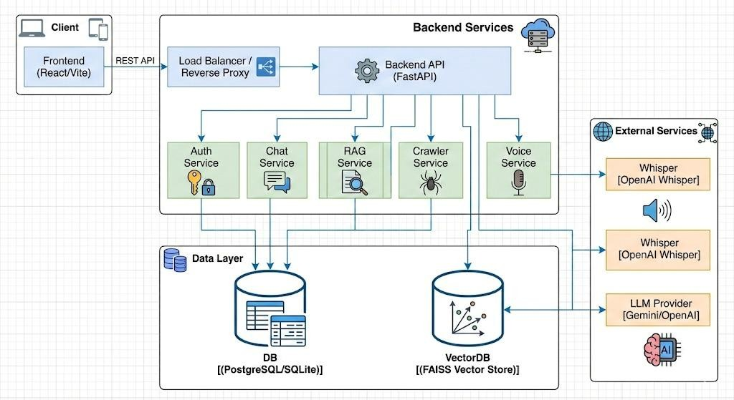

21
Page 27 of 43 - Integrity Submission

5.3 Workflow of the System
The workflow of GovAssist describes how a user query is processed step by step. The process begins when a user enters a question or request through the chatbot interface.

the database for relevant information. Ba
delivered to the user | in the selected language.
First, the system captures the user input and identifies the language used. The input is then processed using NLP techniques to understand the intent of the query. Once the intent is recognized, the system searches sed on the retrieved data, an appropriate response is generated and
5
5

If the query is unclear, the chatbot requests additional information from the user. This step-by-step workflow ensures accurate responses and a smooth user experience.

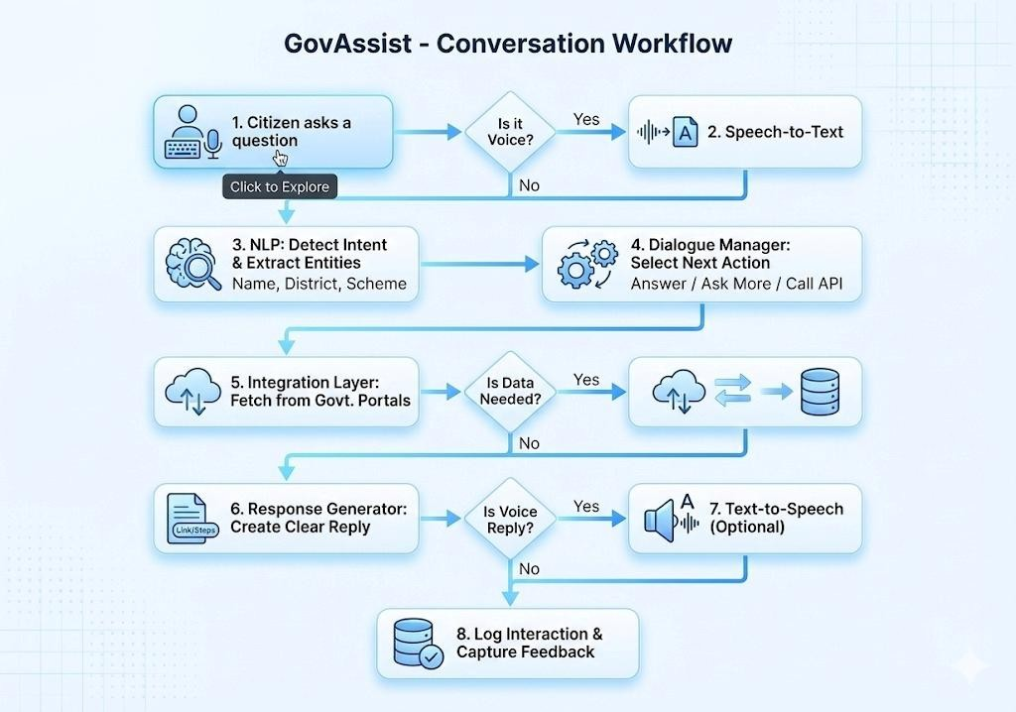

5.4 Module Description
The GovAssist system is divided into different modules to manage tasks efficiently. Each module performs a specific function within the system.
- User Module: Allows citizens to interact with the chatbot and access government services.
- Chatbot Module: Handles conversation flow, intent detection, and response generation.
- Admin Module: Enables government staff to manage schemes, update data, and monitor user queries.
- Database Module: Stores and retrieves government-related information securely.
Modular design improves system organization and makes future enhancements easier to implement.

22
Page 28 of 43 - Integrity Submission

5.5 Use Case Diagram
This diagram illustrates the different ways people and existing systems interact with "GovAssist," an AIpowered chatbot designed to help with electronic governance. It shows three main players: everyday Citizens, Government Administrators, and outside External Govt Systems like databases or APIs. Here is a breakdown of how it works for each of them:
- The Citizen's Experience: For a regular user, GovAssist serves as a 24/7 virtual helper. Citizens can chat with it naturally to ask questions, find information on government schemes and rules, or get step-by-step guidance through official processes. They can also download necessary documents directly through the chat.
- Secure Transactions: For more personal tasks—such as checking the status of an application, filing a grievance, or paying taxes and bills—the system ensures security by asking the citizen to authenticate themselves (like logging in or using eKYC) before proceeding.
- Behind the Scenes: To understand normal human conversation, the bot uses a tool called NLP Intent Recognition. Furthermore, when a citizen asks for live data like an application status, the chatbot acts as a bridge, fetching that information from External Govt Systems.
- The Administrator's Role: Government Administrators work behind the scenes to keep the chatbot accurate by managing its knowledge base and reviewing chat analytics. Importantly, the diagram shows a safety net: if the AI is unsure how to help (low confidence), it can "hand off" the conversation to a human administrator to ensure the citizen gets the right assistance.

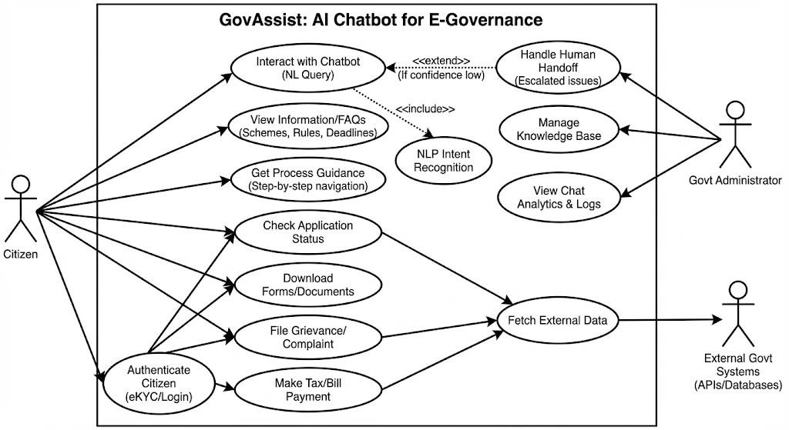

5.6 Conclusion
System design provides a clear blueprint for implementing GovAssist. By defining the architecture, workflow, modules, and database structure, the system is prepared for smooth development and deployment. A well-structured design ensures that GovAssist remains user-friendly, scalable, and reliable while supporting the needs of both citizens and government staff.

23
Page 29 of 43 - Integrity Submission

CHAPTER 6

IMPLEMENTATION

6.1 Introduction
The implementation phase focuses on converting the proposed system design into a working application. In this phase, the actual development of the GovAssist chatbot is carried out by integrating backend logic, database handling, and user interface components. The goal of implementation is to ensure that the system works as expected and provides a smooth and reliable experience to users.

6.2 Tools and Technologies Used
GovAssist is developed using modern and reliable technologies that support scalability and ease of maintenance. The selection of tools is based on system requirements, performance needs, and ease of development. The major tools and technologies used include: -

Frontend (User Interface)
▪ React.js: A JavaScript library for building interactive and dynamic user interfaces.
3
- Vite: A modern build tool and development server that provides fast cold starts and Hot Module Replacement (HMR).
- Tailwind CSS: A utility-first CSS framework used for rapid and responsive UI styling.
- PostCSS: A tool for transforming CSS with JavaScript, used alongside Tailwind.
- ESLint: A static code analysis tool to identify and fix problems in JavaScript code.
3
4
14
24

Backend (API & Logic)
- Python: The core programming language for the server-side logic.
- FastAPI: A modern, high-performance web framework for building APIs with Python.
- Uvicorn: An ASGI web server implementation for Python, used to run the FastAPI application.
- SQLAlchemy: An SQL toolkit and Object-Relational Mapping (ORM) library for database interactions.
- FAISS (Facebook AI Similarity Search): A library for efficient similarity search and clustering of dense vectors, used for the RAG (Retrieval-Augmented Generation) system.
- LangChain / Custom LLM Connector: Logic for integrating with Large Language Models (LLMs) to generate AI responses.
- Pydantic: Data validation and settings management using Python type hints. Database & storage
12
19
27
- SQLite: A lightweight, file-based relational database used for storing user data, chat history, and schemes (indicated by sql_app.db and connection strings).

DevOps & Infrastructure
- Docker: Used for containerizing the application to ensure consistency across different environments (presence of Dockerfile).
- Python venv: Virtual environment tool used for dependency isolation.
- Git: Version control system (implied by the project nature).

Development Tools
- VS Code: The Integrated Development Environment (IDE) used for coding.
- npm (Node Package Manager): Used for managing frontend dependencies and scripts.
- pip: Used for managing Python backend dependencies.

24
Page 30 of 43 - Integrity Submission

6.3 GovAssist Home Page
This figure shows the home page of the GovAssist platform. It provides a brief introduction to the system and its purpose. From this page, users can access key features such as scheme information, eligibility checking, document assistance, and the AI chatbot. The simple layout ensures easy navigation for first-time users.

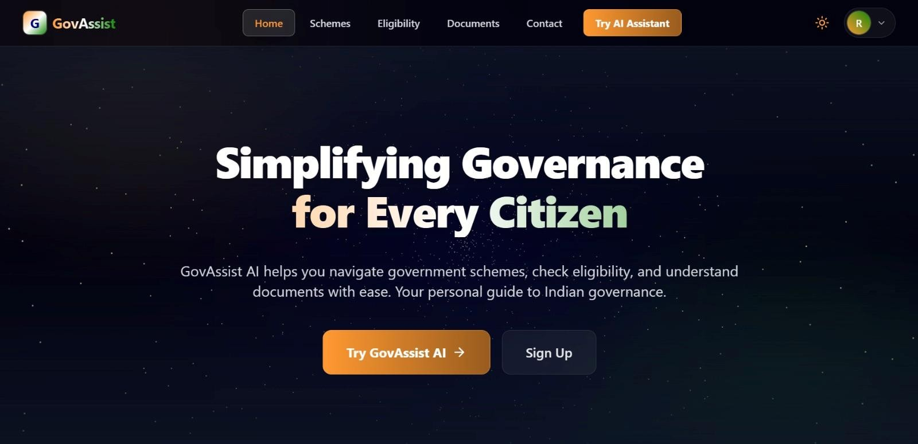

6.4 User Registration Page
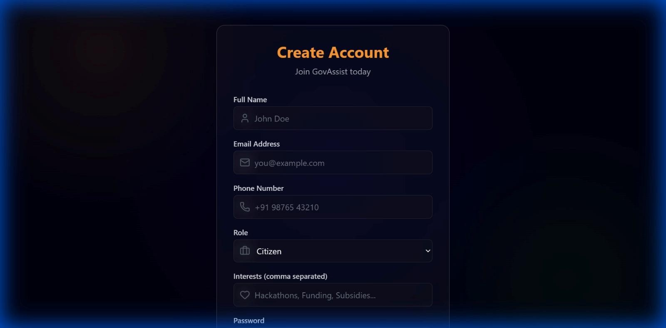
25
Page 31 of 43 - Integrity Submission

6.5 Government Schemes Listing Page
This screen displays a list of available government schemes along with brief descriptions. Users can search and filter schemes based on their requirements and view detailed information for each scheme.

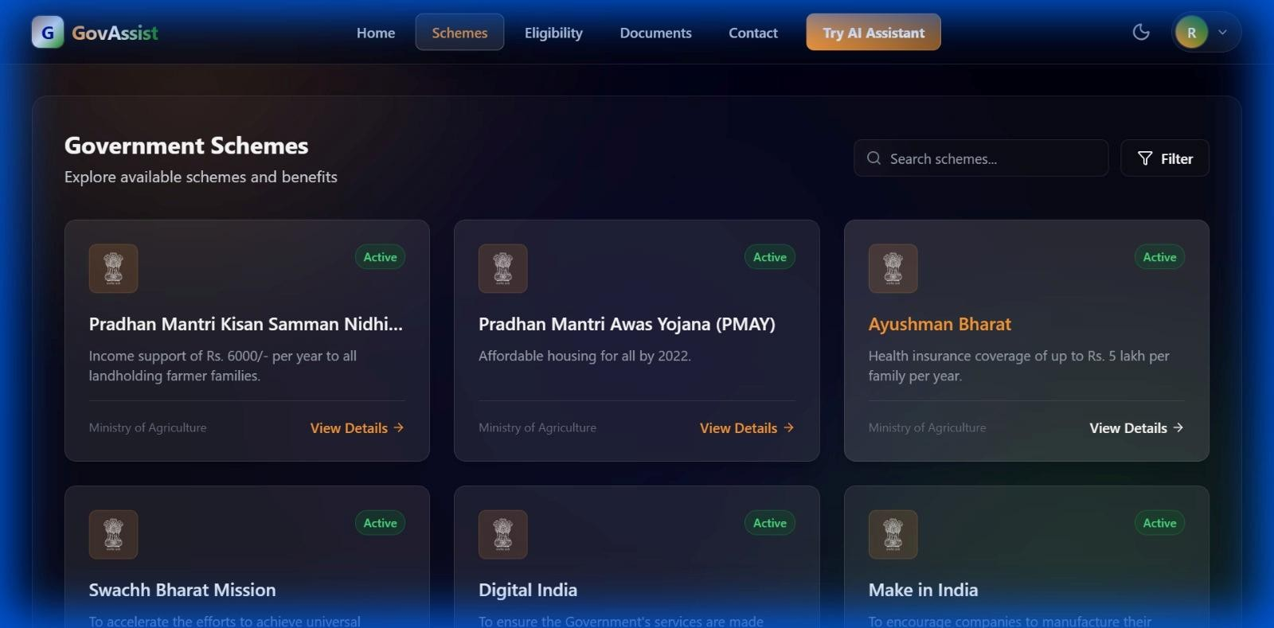

6.6 Eligibility Checking Module
This figure shows the eligibility checking module of GovAssist. Users can enter personal details such as age, income, occupation, and category. Based on the provided information, the system identifies suitable government schemes for the user.

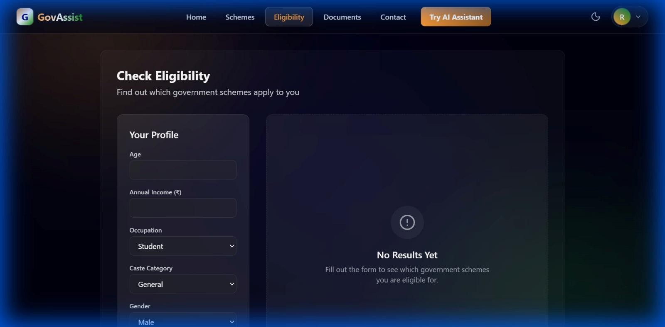

26
Page 32 of 43 - Integrity Submission

6.7 Document Upload Assistance Page
This screen allows users to upload government-related documents such as PDFs or images. The uploaded documents are used to assist users in understanding requirements and completing application processes.

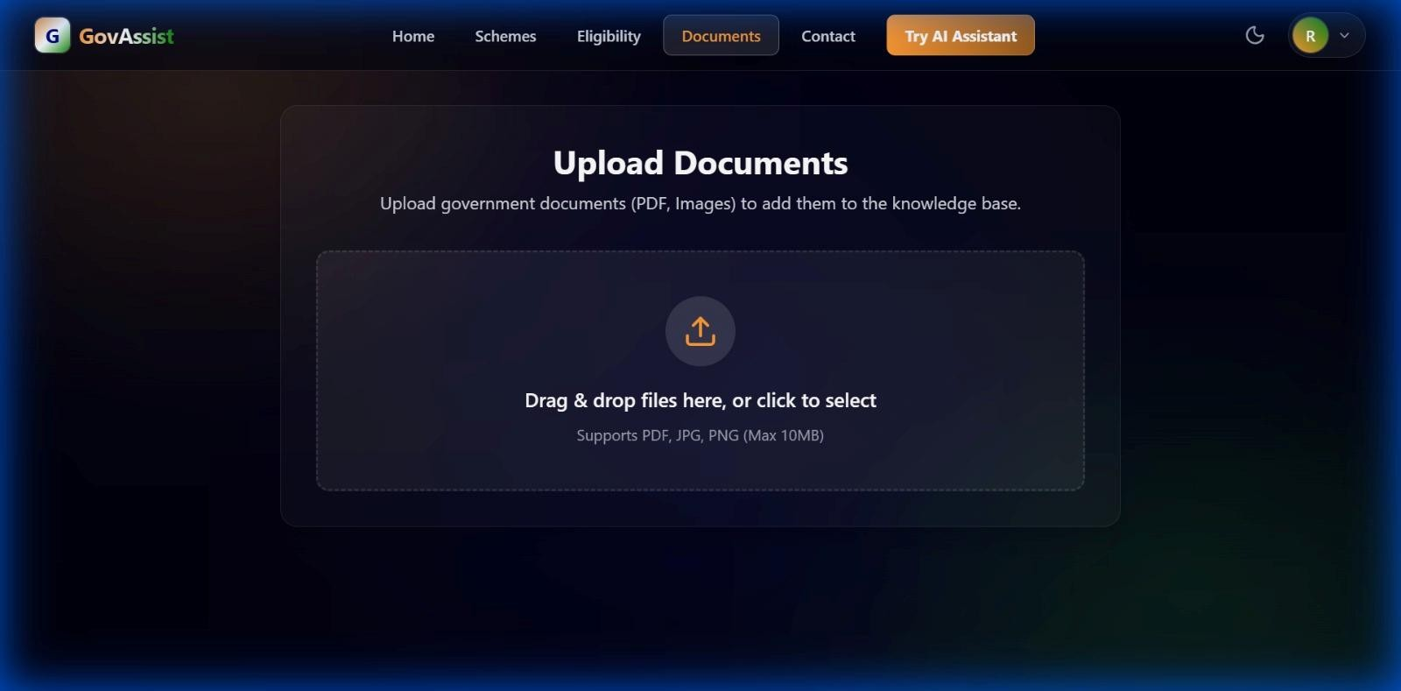

27
Page 33 of 43 - Integrity Submission

6.8 CODE

1. AI Logic (backend/app/services/rag_service.py)
This is the logic for Retrieval-Augmented Generation (RAG). It connects the vector search (retrieval) with the Language Model (generation) to provide accurate answers based on government schemes.

from app.services.llm_connector import llm_connector import sys import os
# Hack to import adapter from parent directory if running as script
sys.path.append(os.path.abspath(os.path.join(os.path.dirname(__file__), "../../../")))
from | adapters.faiss_adapter | import | faiss_adapter
16
def get_rag_response(query: str, history: list = []):
# 1. Retrieve relevant documents
docs = faiss_adapter.similarity_search(query, k=4)

# Format history (Limit to last 10 messages to save tokens) history_text = "" if history: recent_history = history[-10:]
41 history_text = "\n\nConversation History:\n" + "\n".join([f"{msg['role']}: {msg['content']}" for msg in recent_history])
# 2. Construct context if docs:
context_text = "\n\n".join([doc.page_content for doc in docs])
6 system_prompt = """You are GovAssist, a helpful AI assistant for Indian Government schemes and documents.

6 ₃₈ Use the following pieces of retrieved context and the conversation history to answer the user's question. If the context doesn't contain the answer, or if the user is asking a general question (like greeting), answer from your general knowledge.
Do not make up facts about specific government schemes if you don't know them.
IMPORTANT FORMATTING RULES:
- **Structure**: Use clear headings and bullet points.
- **Steps**: If explaining a process, use numbered lists (1., 2., 3.).
- **Links**: If you know the official website or application link, provide it in a dedicated section at the end called "Important Links".
- **Clarity**: Use simple language accessible to all citizens.
If the user's input is gibberish or unintelligible, politely ask them to rephrase. Context:
{context}
{history} """ formatted_prompt = system_prompt.format(context=context_text, history=history_text) else: formatted_prompt = """You are GovAssist, a helpful AI assistant for Indian Government schemes.

The user has asked a question, but no specific documents were found in the database. Answer the user's question from your general knowledge. Be helpful and polite.
28
Page 34 of 43 - Integrity Submission

If the question is about a specific scheme that you don't know about, admit it and suggest they upload the relevant document.
6
IMPORTANT FORMATTING RULES:
- **Structure**: Use clear headings and bullet points.
- **Steps**: If explaining a process, use numbered lists.
- **Links**: Provide official links if known.
{history} """
formatted_prompt = formatted_prompt.format(history=history_text)
# 3. Generate response
answer = llm_connector.generate_response(formatted_prompt, query)

# Post-filter check from app.utils.sanitizer import is_valid_response if not is_valid_response(answer):
answer = "I couldn't produce a dependable response based on the available information. Here are some steps you can try:\n1. Rephrase your question with more specific details.\n2. Upload a relevant document if you have one.\n3. Check official government portals directly."

# 4. Format sources
35 sources = [{"title": doc.metadata.get("source", "Unknown"), "content": doc.page_content[:100] + "..."} for doc in docs] if docs else []

return {
"answer": answer,
"sources": sources
}

2. Database Connection File (backend/app/core/database.py)
This is the database connection using SQLAlchemy. It sets up the engine and a session factory (SessionLocal).

e
from sqlalchemy import create_engin

from sqlalchemy.ext.declarative import declarative_base

from sqlalchemy.orm import sessionmake
r

from
app.core
.config import settings

engine = create_engine(

False}
settings.DATABASE_URL, connect_args={"check_same_thread":

)

)
SessionLocal = sessionmaker(autocommit=False, autoflush=False, bind=engine

)
Base = declarative_base(

def get_db():

onLocal()
db = Sessi

try
:

yield d
b

finally:

2
2

db.close()

29
Page 35 of 43 - Integrity Submission

3. API File (backend/app/main.py)
- This is the main entry point of the backend application. It initializes the FastAPI app, sets up CORS (Cross-Origin Resource Sharing), connects the database, and creates the default admin user.

- from fastapi import FastAPI from fastapi.middleware.cors import CORSMiddleware
from app.core.config import settings from app.core.database import engine, Base
# Import all models to ensure they are registered with Base from app.models import user, chat, document, scheme
app = FastAPI(title=settings.PROJECT_NAME, version="0.1.0")
4
37
39
@app.on_event("startup") def startup_db_client():
Base.metadata.create_all(bind=engine)

# Create default admin user from sqlalchemy.orm import Session from app.core.database import SessionLocal from app.models.user import User from app.core.security import get_password_hash

db = SessionLocal() try:
admin_email = "admin@govassist.ai" existing_admin = db.query(User).filter(User.email == admin_email).first() if not existing_admin: admin_user = User( email=admin_email, hashed_password=get_password_hash("admin123"), full_name="System Admin",
2
role="admin", is_admin=True,
interests="[]"
)
db.add(admin_user)
db.commit()
print(f"Admin user created: {admin_email} / admin123") 40 except Exception as e: print(f"Error creating admin user: {e}") finally:
app.add_middleware(
CORSMiddleware,
db.close() 11

allow_origins=["*"], allow_credentials=True, allow_methods=["*"], allow_headers=["*"],
30
Page 36 of 43 - Integrity Submission

)

@app.get("/api/health") def health_check():
return {"status": "ok"}
3 from app.api.api import api_router app.include_router(api_router, prefix=settings.API_V1_STR)

• Descriptions for each file:

1. AI Logic & RAG Service (backend/app/services/rag_service.py)

Description: This file implements the core intelligence of the GovAssist platform using a Retrieval-Augmented Generation (RAG) architecture. It acts as the bridge between the user's natural language queries, the vector database, and the Large Language Model (LLM). Instead of relying solely on the LLM's pre-trained knowledge, this service dynamically retrieves specific government documents related to the user's query to generate accurate, fact-based responses.

Key Responsibilities:
Context Retrieval: Uses faiss_adapter to perform a semantic similarity search in the vector database, finding the most relevant government schemes or document chunks.
Prompt Engineering: Dynamically constructs a "System Prompt" that instructs the AI to act as "GovAssist," enforcing strict formatting rules (headings, steps, links) and injecting the retrieved context and conversation history.
Response Generation: Sends the enriched prompt to the LLM via llm_connector to generate the final answer. Validation & Sourcing: Includes logic to validate the response and aids transparency by citing the specific source documents used to generate the answer.

2. Database Connection (backend/app/core/database.py)

Description: This module serves as the centralized data access layer for the application. It configures the connection to the persistent relational database (SQLite) using SQLAlchemy, a powerful Object-Relational Mapper (ORM) for Python. This file ensures that a robust and thread-safe connection pool is available for the entire application to use.

Key Responsibilities:
Engine Configuration: Initializes the database engine using the connection URL from the application settings. Session Management: Creates a SessionLocal factory that generates temporary database sessions for individual requests, ensuring transactions are isolated and handled correctly.
Dependency Injection: Provides the get_db utility function to efficiently yield database sessions to API endpoints and automatically close them after a request finishes, preventing resource leaks.

3. API Entry Point (backend/app/main.py)

Description: This file is the main entry point for the backend server, built using the FastAPI framework. It 31
Page 37 of 43 - Integrity Submission

orchestrates the entire backend application by initializing the server, setting up security protocols, and wiring together the database, data models, and API routes. It ensures the environment is ready for operation immediately upon startup.

Key Responsibilities:
Server Initialization: Creates the FastAPI application instance and defines global configurations like the API title and version.
CORS Configuration: Sets up Cross-Origin Resource Sharing (CORS) middleware to allow the frontend application to securely communicate with the backend API.
Startup Events: Automates critical initialization tasks, such as creating all database tables if they don't exist and auto-generating a default System Admin account for immediate administrative access.
Route Registration: Aggregates and includes all API routers (endpoints) from different modules into the main application under a unified version prefix (e.g., /api/v1).

32
Page 38 of 43 - Integrity Submission

REFERENCES

- M. E. Cortés-Cediel, A. Segura Tinoco, I. Contador, and M. P. Rodríguez Bolívar, “Trends and Challenges of E-Government Chatbots: Advances in Exploring Open Government Data and Citizen Participation,” Government Information Quarterly, vol. 40, no. 2, 2023.

- R. Zhang and L. Nie, “Enhancing Citizen–Government Communication Using Artificial Intelligence,” arXiv preprint, 2025. Available: https://arxiv.org/abs/2501.10715

- J. Zhou, R. Shen, Y. You, C. DiSalvo, L. Dombrowski, and C. MacLellan, “Improving Public Service Chatbot Design and Civic Impact,” arXiv preprint, 2025. Available: https://arxiv.org/abs/2506.12259

- J. Bright, F. Enock, S. Esnaashari, J. Francis, Y. Hashem, and D. Morgan, “Generative Artificial Intelligence in the Public Sector,” arXiv preprint, 2024. Available: https://arxiv.org/abs/2401.01291

- Wuttke, A. Rauchfleisch, and A. Jungherr, “Artificial Intelligence in Government: Public Perception and Trust,” arXiv preprint, 2025. Available: https://arxiv.org/abs/2505.01085

- United Nations, “E-Government Survey: Digital Government in the Decade of Action,” United Nations Department of Economic and Social Affairs, 2022.

- Government of India, “Digital India Programme,” Ministry of Electronics and Information Technology (MeitY). Available: https://www.digitalindia.gov.in

- Goodfellow, Y. Bengio, and A. Courville, Deep Learning, MIT Press, 2016.

- D. Jurafsky and J. H. Martin, Speech and Language Processing, Pearson Education, 2nd Edition.

- Oracle, “Introduction to Chatbot Technologies,” Oracle Documentation, 20
33
Page 39 of 43 - Integrity Submission

Appendices

APPENDICES

Appendix A: Project Directory Structure
A high-level overview of the project's file organization system.

backend/: Contains all server-side logic, API definitions, and database configurations. app/api/: API route definitions. app/core/: Core configurations (Database, Security). app/services/: Business logic (RAG, LLM Connector). frontend/: Contains the client-side user interface code. src/components/: Reusable UI components. src/pages/: Individual application pages (Home, Chat, Login).

Appendix B: Key API Endpoints
A summary of the primary REST API endpoints exposed by the backend:

GET /api/health: Health check endpoint to verify system status.
POST /api/v1/auth/login: Authenticates a user and returns an access token.
POST /api/v1/chat/response: Sends a user query to the RAG service and retrieves an AI-generated answer.
GET /api/v1/schemes: Retrieves a list of available government schemes.

Appendix C: Installation Guidelines
Steps to set up the development environment:
3

Backend Setup:
cd backend
pip install -r requirements.txt python -m uvicorn app.main:app --reload Frontend Setup:
3
cd frontend npm install
npm run dev

Appendix D: Database Schema Overview
Brief description of the primary data models used in the SQLite database:

User Table: Stores user credentials, profile information, and roles (e.g., Admin, Citizen).
Scheme Table: Contains details about government schemes, including eligibility criteria and benefits.
Chat History Table: Logs conversation history between users and the AI assistant for context retention.

34
Page 40 of 43 - Integrity Submission
Appendices

APPENDIX - E

Abbreviation Full Form
API Application Programming Interface
AI Artificial Intelligence
17 CORS Cross-Origin Resource Sharing
CSS Cascading Style Sheets
DB Database
DOM Document Object Model
HMR Hot Module Replacement (Vite Feature)
22 HTTP Hypertext Transfer Protocol
JSON JavaScript Object Notation
LLM Large Language Model
ML Machine Learning
ORM Object-Relational Mapping (SQLAlchemy)
RAG Retrieval-Augmented Generation
26 REST Representational State Transfer
SQL Structured Query Language
UI User Interface
UX User Experience

35
Page 41 of 43 - Integrity Submission
trn:oid:::3618:124683685

Plagiarism Report

PLAGIARISM
REPORT
36
Page 42 of 43 - Integrity Submission

trn:oid:::3618:124683685

RESEARCH PAPER
MANUSCRIPT

37
Page 43 of 43 - Integrity Submission

